

DRAFT
Technical Design

Melbourne IT OFC
MIT Bank Accounts Audit Report

Author: Tony Whelan
Creation Date: 19 April 2017
Last Updated: 28 April 2017
Version: 1.0
Table of Contents

1. Requirement 3
2. Solution Overview 3
3. Technical Objects 4
3.1 BI Publisher XML Data Definition File 4
3.2 BI Publisher RTF Report Template 4
4. Configuration 4
4.1 Define Value Sets 4
4.2 Define Concurrent Program 4
4.3 Define XML Data Definition 6
4.4 Define XML Template 6
4.5 Update Request Group 6
5. Report Execution 8

Requirement

Melbourne IT switched on detailed audit security for a number of bank account tables and columns. They have a requirement for a custom report to list inserts, updates and deletions on the audited tables.

Solution Overview

The MIT Bank Accounts Audit Report has been developed and configured using the Oracle EBS XML BI Publisher. This document describes the configuration and execution of XML Report MIT Bank Accounts Audit Report to provide the required audit information.

The available Parameters for the report include:
Bank Account Name: (Optional)
Audit Date From: (Mandatory)
Audit Date To: (Mandatory)

The following columns are included in the report:
Transaction Type: (Current, Insert, Update, Delete)
Created or Update By:
Time Stamp:
Bank Account ID:
Bank Account Name:
Bank Account Number:
IBAN Code:

The report is sorted in Bank Account ID order. The current row in the standard application table is listed first followed by any historical transaction changes in the security audit tables.

Technical Objects

BI Publisher XML Data Definition File
This file contains the SQL query, data elements and parameters for the report.


BI Publisher RTF Report Template
This file contains the xml markup and report layout definition for the report.


Configuration

Define Value Sets
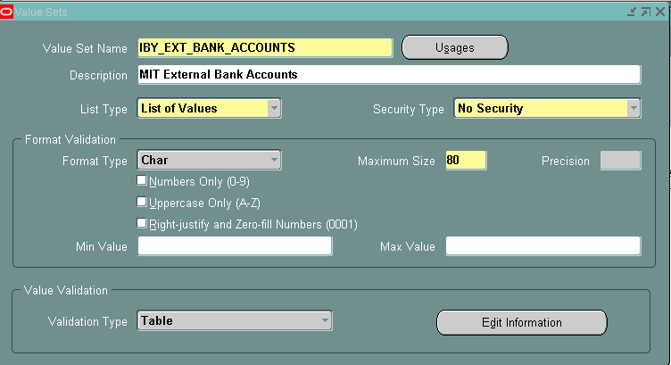

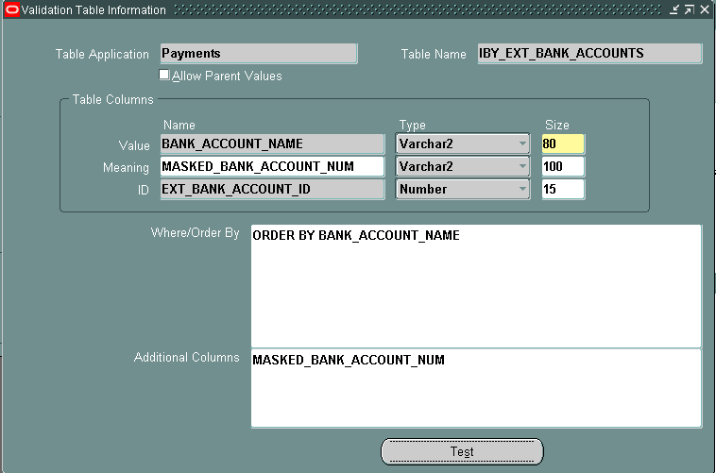

Define Concurrent Program
Responsibility: System Administrator
Menu Path: Concurrent -> Program -> Define
Form: Concurrent Program
Purpose: Define a new concurrent program.
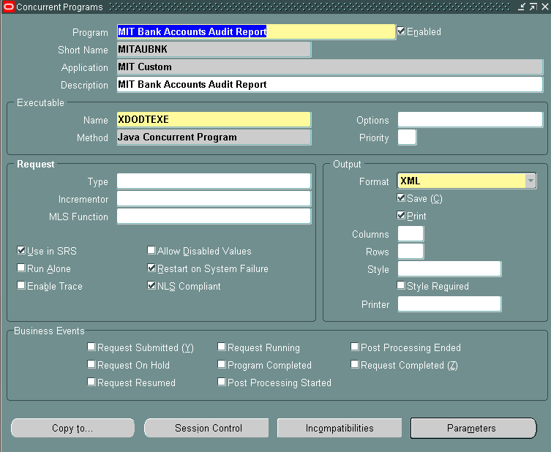

Parameters:
Seq. | Parameter | Value Set | Disp. Size | Prompt | Token
10 | Bank Account | IBY_EXT_BANK_ACCOUNTS | 80 | Bank Account | P_BANK_ACCOUNT
20 | Audit Date From | FND_STANDARD_DATETIME | 20 | Audit Date From | P_AUDIT_DATE_FROM
30 | Audit Date To | FND_STANDARD_DATETIME | 20 | Audit Date To | P_AUDIT_DATE_TO

Define XML Data Definition
Responsibility: XML Publisher
Menu Path: Home -> Data Definitions
Form: Data Definition
Purpose: Define the Data Definition in XML Publisher; attach the XML Data Definition file.

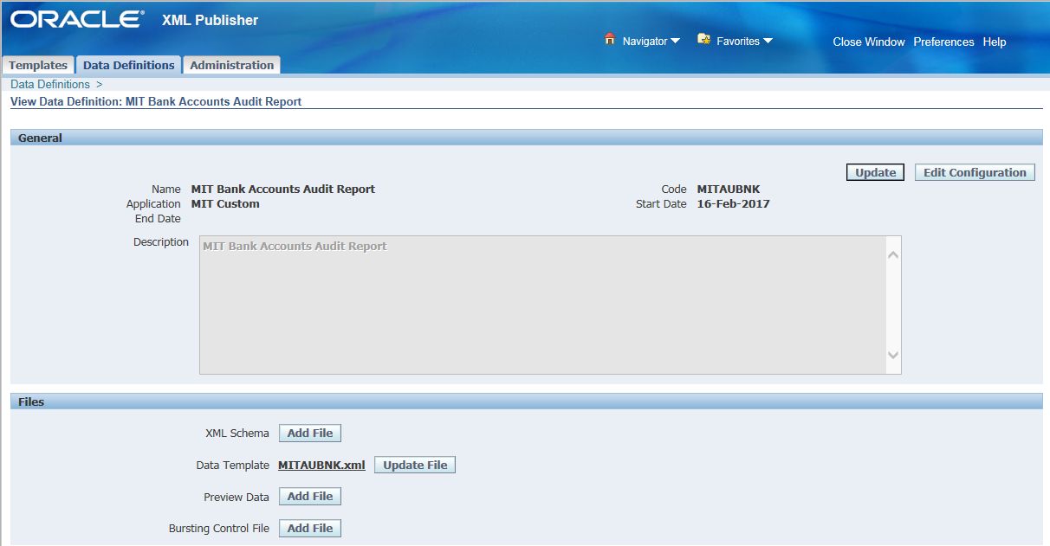

Define XML Template
Responsibility: XML Publisher
Menu Path: Home -> Templates
Form: Templates
Purpose: Define the Layout Template; attach the RTF Report Template file.

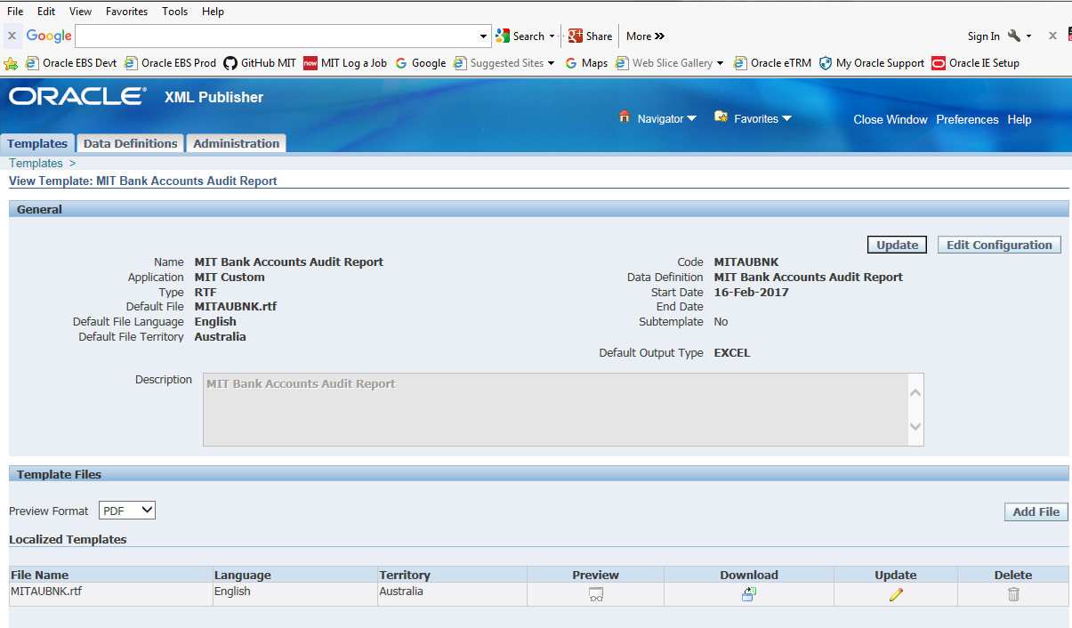

Update Request Group
Responsibility: System Administration
Menu Path: Security-> Responsibility -> Define
Form: Request Group
Purpose: Add the Report to the General Ledger Request Group

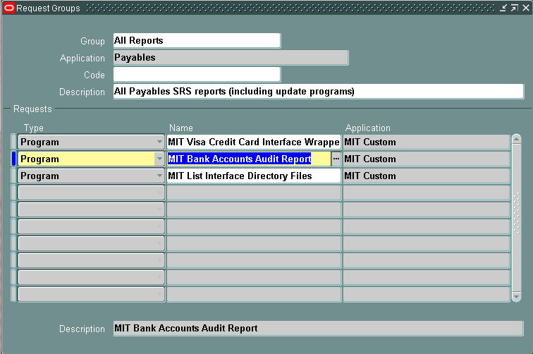

Report Execution

- Login to your OFC General Ledger Responsibility and execute the Concurrent Requests program.
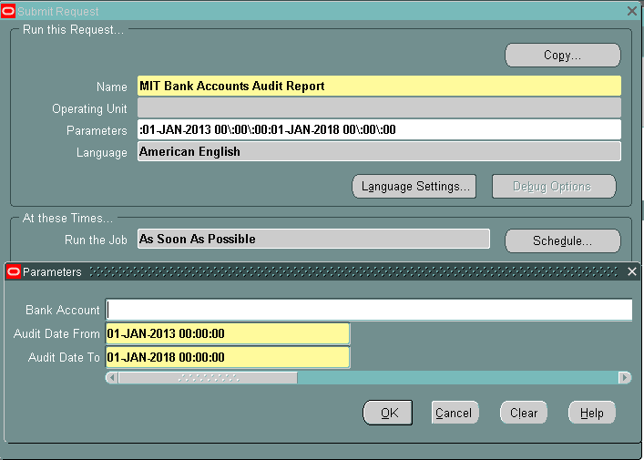

- Enter or select MIT Bank Accounts Audit Report.
- Enter or select the required Parameters for the report data:-
  - Bank Account
  - Audit Date From
  - Audit Date To
- Submit the Report.
- Execute the View -> Requests menu.
- Click the View Output button in OFC Requests form
- Click the Open or Save option in the Internet Explorer window. This will save the report in your standard Downloads folder.

- Navigate to your Downloads folder and open the report file.

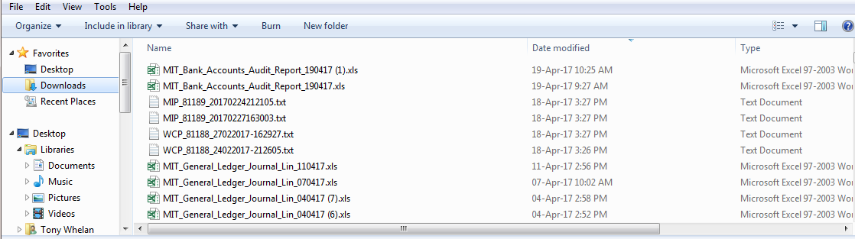

- Click ‘Yes’ to ignore the file format extension warning.
- The report output will be displayed in Excel format.

